Synthesis stage:

* STA:

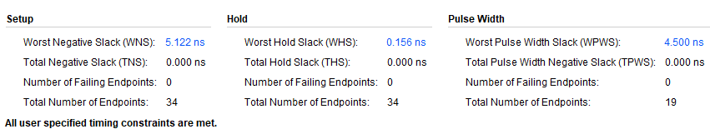

* Power Analysis:

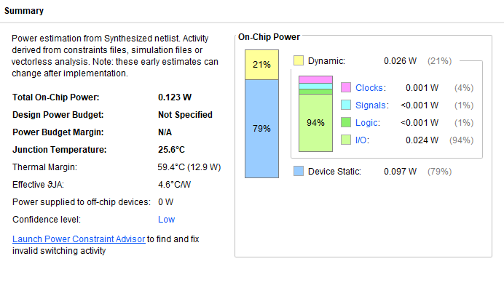

* Utilization Report:

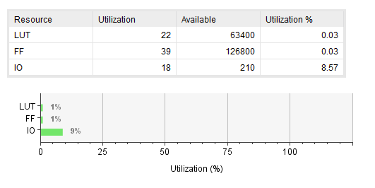

Implementation:

* STA:

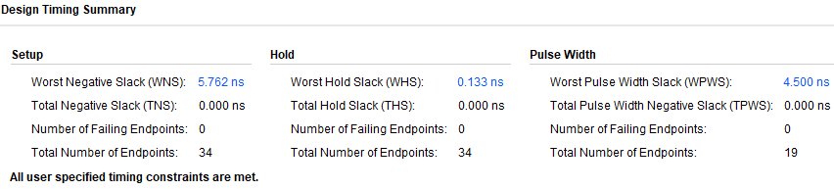

* Power Analysis:

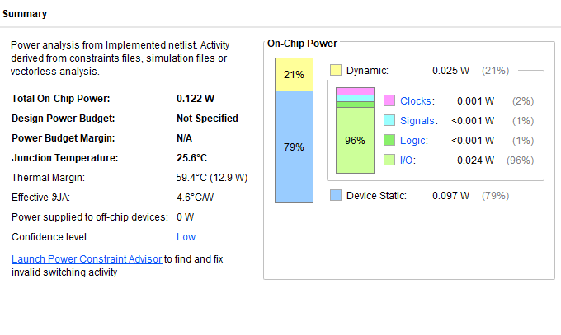

* Utilization Report:

